# **Name: Abdurrahman Qureshi**

# **Roll No: 210451**

Practical No: 5

**1)Vowel Check**

**CODE:**

Module Module1

Sub main()

Dim userInputChar As Char

userInputChar = InputBox("Enter any character")

Select Case (userInputChar)

Case "a"

Console.WriteLine("The character " & userInputChar & " is an Vowel")

Case "e"

Console.WriteLine("The character " & userInputChar & " is an Vowel")

Case "i"

Console.WriteLine("The character " & userInputChar & " is an Vowel")

Case "o"

Console.WriteLine("The character " & userInputChar & " is an Vowel")

Case "u"

Console.WriteLine("The character " & userInputChar & " is an Vowel")

Case Else

Console.Write("The character " & userInputChar & " is either a number/special character/ or a consonant")

End Select

Console.ReadLine()

End Sub

End Module

**OUTPUT:**

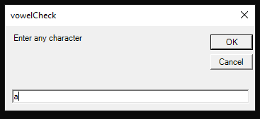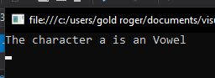

**2)Menu Month**

**CODE:**

Module Module1

Sub Main()

Dim choice As Integer

choice = InputBox("Enter your choice")

Select Case (choice)

Case 1

Console.WriteLine("Jan")

Case 2

Console.WriteLine("Feb")

Case 3

Console.WriteLine("Mar")

Case 4

Console.WriteLine("Apr")

Case 5

Console.WriteLine("May")

Case 6

Console.WriteLine("Jun")

Case 7

Console.WriteLine("Jul")

Case 8

Console.WriteLine("Aug")

Case 9

Console.WriteLine("Sep")

Case 10

Console.WriteLine("Oct")

Case 11

Console.WriteLine("Nov")

Case 12

Console.WriteLine("Dec")

End Select

End Sub

End Module

**OUTPUT:**

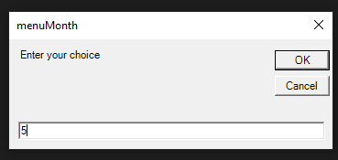

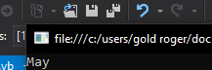

**3)Arithmetic Menu**

**CODE:**

Module Module1

Sub Main()

Dim a As Integer

Dim b As Integer

Dim c As Char

a = InputBox("Enter first Number")

b = InputBox("Enter Second Number")

c = InputBox("Enter operator")

Select Case (c)

Case "+"

Console.ReadLine("Addition = " & a + b)

Case "-"

Console.ReadLine("Subtraction = " & a - b)

Case "*"

Console.ReadLine("Multiplication = " & a * b)

Case "/"

Console.ReadLine("Division = " & a / b)

End Select

End Sub

End Module

**OUTPUT:**

